PROJECT DOCUMENTATION
Multi-Site Active Directory
with Zabbix Monitoring
Table of Contents
1. Project Overview 3
1.1 Objective 3
1.2 Scope 3
1.3 Architecture Diagram 3
1.4 Server & IP Inventory 4
2. Active Directory 5
2.1 Forest & Domain Design 5
2.2 Domain Controllers 5
2.3 DNS & Delegation 6
2.4 Sites and Services 6
2.5 FSMO Roles 8
2.6 OUs, Groups and Group Policy 9
2.7 Additional Evidence 11
a) Replication health 11
b) RODC configuration 12
3. Zabbix Monitoring 13
3.1 Zabbix Server Overview 13
3.2 Zabbix Agent 2 Configuration 14
3.3 Service Account (gMSA) & Access 15
3.4 Items 16
3.5 Discovery Rules 19
3.6 Triggers 20
3.7 Telegram Notifications 21
3.8 Dashboard 23
3.9 LDAP Authentication & JIT Users 24
3.9.1 LDAP Bind Account vs gMSA 26
3.10 Logs 28
4. Testing & Validation 29
5. Troubleshooting Log 30

1. Project Overview

1.1 Objective
The goal of this project was to build a multi-site Active Directory forest and monitor it end to end. The forest root domain diaa.local has two child domains (cairo.diaa.local and giza.diaa.local), an additional domain controller, a read-only domain controller (RODC), DNS delegation to the child domains and site-aware replication across four AD sites. The whole environment runs in Azure and was provisioned with Terraform. Zabbix 7.0 monitors every domain controller through Zabbix Agent 2, authenticates its users against Active Directory over LDAP with just-in-time (JIT) provisioning, and sends alerts to a Telegram group.

1.2 Scope
- Infrastructure: one Azure VNet with a subnet per server and Azure Bastion for administrative access, all deployed with Terraform
- Active Directory: PDC, additional DC, RODC, Cairo child domain, Giza child domain
- DNS delegation, AD Sites and Services, replication between sites
- Zabbix: agent monitoring of DCs, gMSA service account, LDAP login with JIT provisioning, triggers and Telegram alerts
- Out of scope: Exchange, AD FS, backup and disaster recovery

1.3 Architecture Diagram
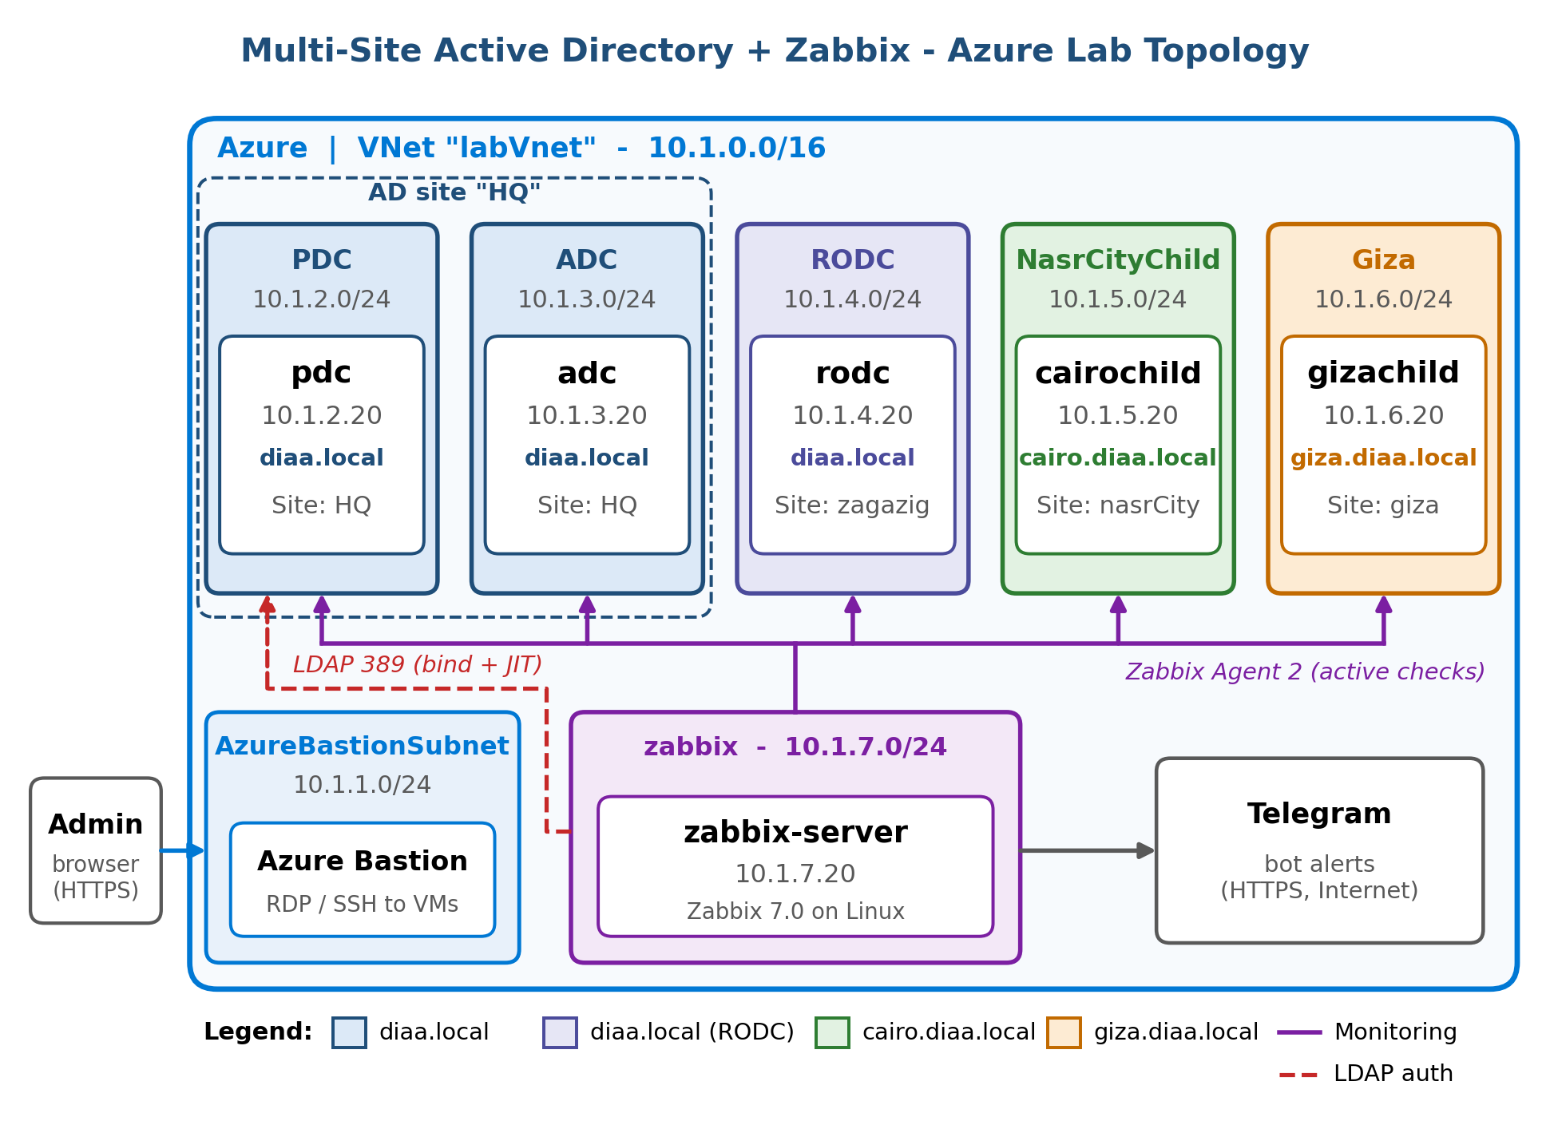
Figure 1: Azure lab topology - subnets, AD sites, domains and monitoring flow
All servers sit in one Azure VNet, labVnet (10.1.0.0/16), with one /24 subnet per server. Private IP addresses are static (the .20 address of each subnet), which keeps the DNS records, AD site subnets and Zabbix host interfaces stable.
Subnet | Address prefix | Contents
AzureBastionSubnet | 10.1.1.0/24 | Azure Bastion - browser-based RDP/SSH access to all VMs
PDC | 10.1.2.0/24 | pdc (10.1.2.20)
ADC | 10.1.3.0/24 | adc (10.1.3.20)
RODC | 10.1.4.0/24 | rodc (10.1.4.20)
NasrCityChild | 10.1.5.0/24 | cairochild (10.1.5.20)
Giza | 10.1.6.0/24 | gizachild (10.1.6.20)
zabbix | 10.1.7.0/24 | zabbix-server (10.1.7.20)

1.4 Server & IP Inventory
Host name | Role | Domain | AD site | IP address | OS
pdc | Primary DC, Global Catalog, FSMO holder | diaa.local | HQ | 10.1.2.20 | Windows Server 2022
adc | Additional DC, Global Catalog, Infrastructure Master | diaa.local | HQ | 10.1.3.20 | Windows Server 2022
rodc | Read-only DC, Global Catalog | diaa.local | zagazig | 10.1.4.20 | Windows Server 2022
cairochild | Cairo child domain DC | cairo.diaa.local | nasrCity | 10.1.5.20 | Windows Server 2022
gizachild | Giza child domain DC | giza.diaa.local | giza | 10.1.6.20 | Windows Server 2022
zabbix-server | Zabbix 7.0 monitoring server | - | - | 10.1.7.20 | Linux

2. Active Directory

2.1 Forest & Domain Design
Description
The forest root domain diaa.local was created on the PDC and two child domains, cairo.diaa.local and giza.diaa.local, were added to it, giving one forest with three domains. Every domain controller is also a Global Catalog server, so logons and forest-wide searches are served locally in each site.
Item | Value
Forest root domain | diaa.local
Child domains | cairo.diaa.local, giza.diaa.local
Forest / domain functional level | Windows Server 2016
Global Catalog servers | All five DCs: pdc, adc, rodc, cairochild, gizachild

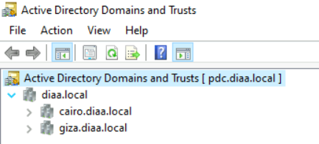
Figure 2: Active Directory Domains and Trusts / forest structure

2.2 Domain Controllers
Description
Each domain has its own domain controllers, shown here in Active Directory Users and Computers: pdc, adc and rodc in diaa.local, cairochild in cairo.diaa.local and gizachild in giza.diaa.local. The DC Type and Site columns confirm that every DC is a Global Catalog, that rodc is read-only, and which AD site each DC belongs to.
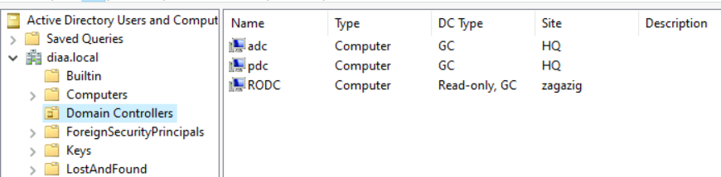
Figure 3: Domain controllers of diaa.local (pdc, adc, rodc)
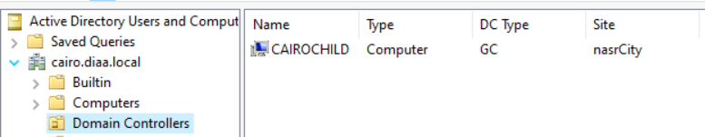
Figure 4: Cairo child domain controller
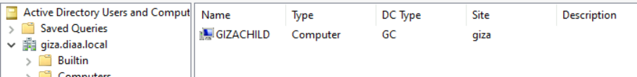
Figure 5: Giza child domain controller

2.3 DNS & Delegation
Description
The diaa.local DNS zone is hosted on the root domain controllers, and the cairo and giza child zones are delegated to the DCs of their own domains. Each child domain therefore resolves its names locally, while every client can still find all domains through the root. The DNS console also shows the _msdcs, _sites, _tcp and _udp service-record zones that Active Directory creates.
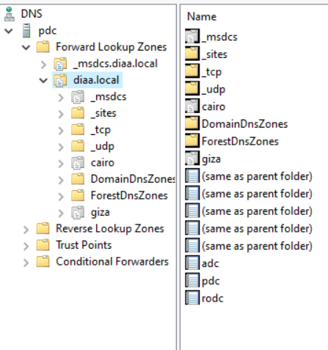
Figure 6: DNS zones and delegation for child domains

2.4 Sites and Services
Description
AD sites describe the network topology so that clients and replication use the closest, cheapest path. HQ holds pdc and adc, zagazig holds rodc, nasrCity holds cairochild and giza holds gizachild. Each Azure subnet is mapped to its site, and site links from HQ to each other site (cost 100, replication every 15 minutes) control inter-site replication.
Site | Subnet | Domain controllers
HQ | 10.1.2.0/24, 10.1.3.0/24 | pdc, adc
nasrCity | 10.1.5.0/24 | cairochild
giza | 10.1.6.0/24 | gizachild
zagazig | 10.1.4.0/24 | rodc

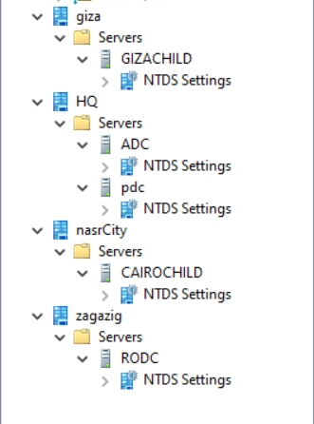
Figure 7: AD Sites and Services — sites and servers
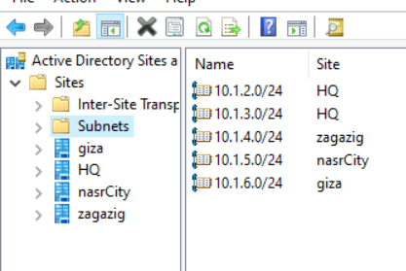
Figure 8: Subnets mapped to sites
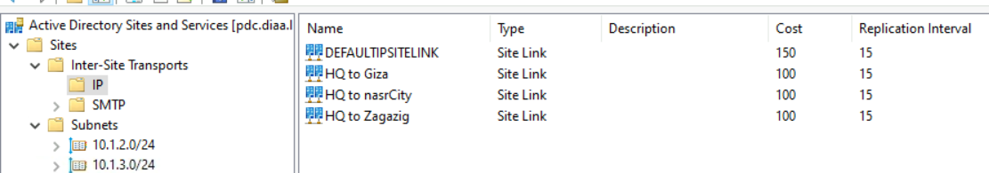
Figure 9: Site links and replication interval

2.5 FSMO Roles
Five roles exist: two are forest-wide (one holder in the whole forest) and three are domain-wide (one holder per domain). The RODC cannot hold any role. Roles are split in the root domain so the PDC does not carry everything: the Infrastructure Master was moved to ADC. Normally the Infrastructure Master should not sit on a Global Catalog server in a multi-domain forest, but because every DC in this forest is a Global Catalog the placement has no functional impact.
Domain | Role | Scope | Holder
diaa.local | Schema Master | Forest | pdc
diaa.local | Domain Naming Master | Forest | pdc
diaa.local | PDC Emulator | Domain | pdc
diaa.local | RID Master | Domain | pdc
diaa.local | Infrastructure Master | Domain | adc
cairo.diaa.local | PDC Emulator / RID / Infrastructure | Domain | cairochild
giza.diaa.local | PDC Emulator / RID / Infrastructure | Domain | gizachild
- | All roles | - | rodc: none (not supported)

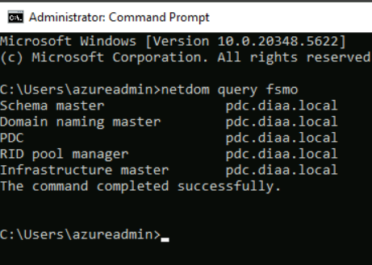
Figure 10: netdom query fsmo — BEFORE the role move
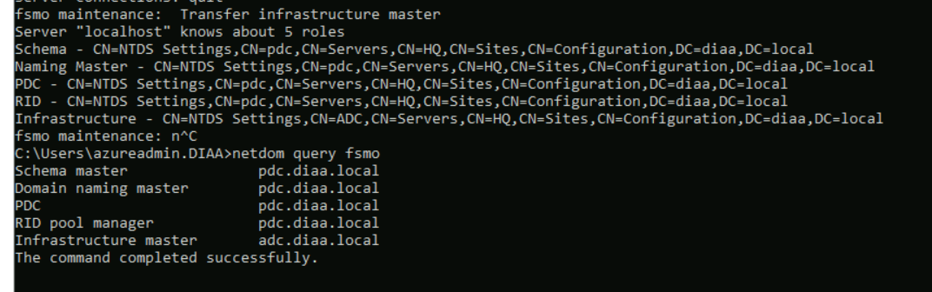
Figure 11: netdom query fsmo — AFTER the role move
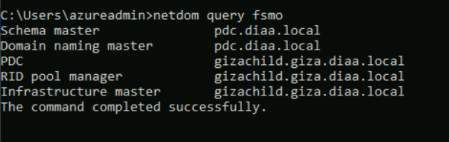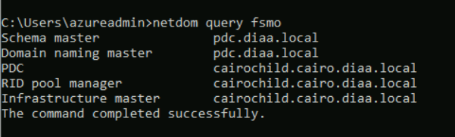
Figure 12: netdom query fsmo in the Cairo and Giza child domains

2.6 OUs, Groups and Group Policy
Rather than a generic OU tree, the directory objects here exist for a specific purpose: scoping and authorising Zabbix.
Object | Name | Purpose
OU | zabbixUsers | LDAP search scope: the Base DN in Zabbix points here, so only accounts in this OU can sign in to Zabbix
OU | zabbixSearch | Holds the LDAP bind (service) account, kept apart from the users it searches
Security groups | zabbixUsers / zabbixGuests | Matched by Zabbix through memberOf: zabbixUsers maps to Zabbix administrators (Super admin role), zabbixGuests maps to Guests (Guest role)
Test user 1 | zab | Member of zabbixUsers: proves LDAP login and JIT provisioning with the admin role
Test user 2 | zab-gust | Member of zabbixGuests: proves group mapping gives different permissions (read-only guest)
Bind account | zabbix-search | Service account Zabbix uses to bind and search AD (see 3.9.1)
GPO | Zabbix gpo | Grants the gMSA access to the Zabbix Agent 2 folder on all DCs

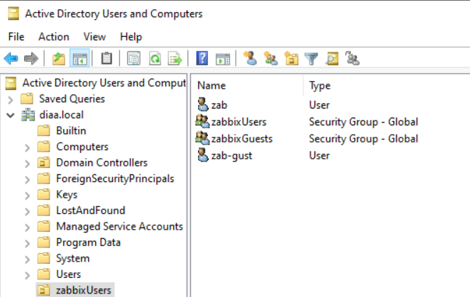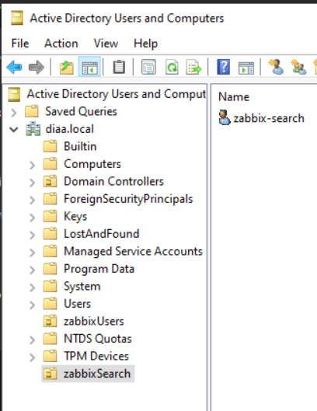
Figure 13: OU structure - zabbixUsers (users and groups) and zabbixSearch (bind account)

2.7 Additional Evidence

a) Replication health
repadmin /replsummary shows inbound and outbound replication between all domain controllers with no failures, and repadmin /showrepl lists each replication partner per naming context with the time and result of the last attempt.
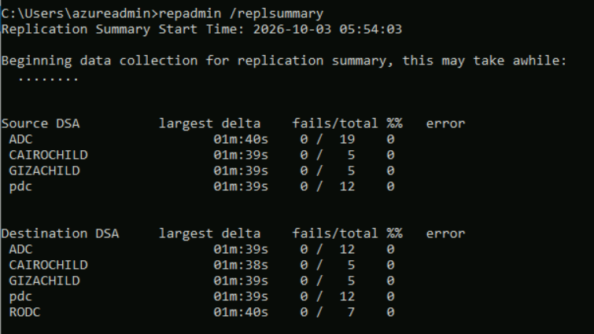
Figure 14: repadmin /replsummary output
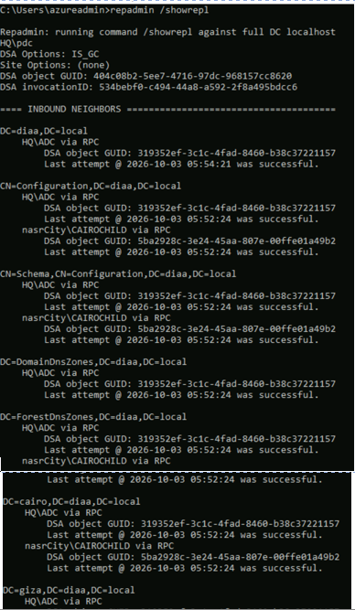
Figure 15: repadmin /showrepl output

b) RODC configuration
The RODC is controlled by a Password Replication Policy. The Allowed and Denied lists decide whose passwords may be cached, and the Advanced view lists the accounts whose passwords are actually cached on the RODC: only three objects, which shows that caching is limited to the accounts that need it.
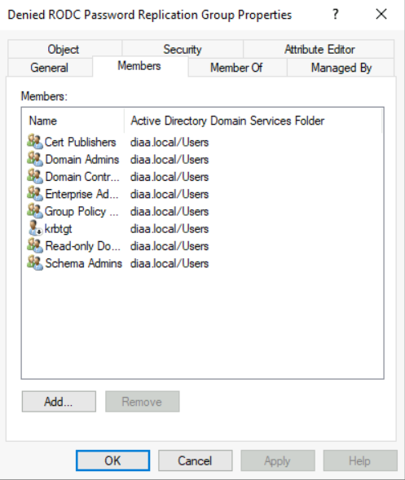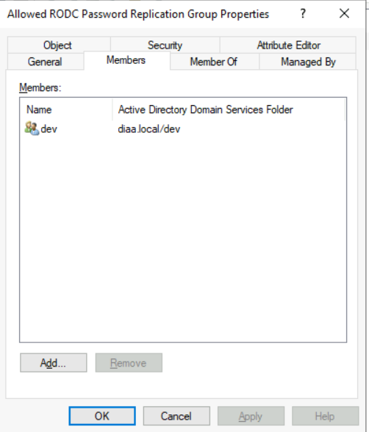
Figure 16: Password Replication Policy tab (Allowed / Denied RODC Groups)
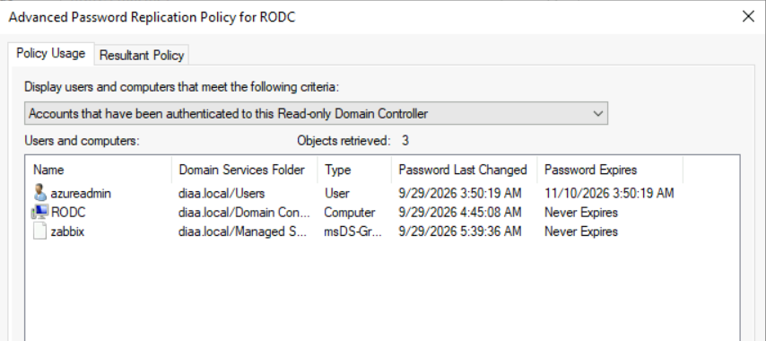
Figure 17:

3. Zabbix Monitoring

3.1 Zabbix Server Overview
Description
Zabbix 7.0 runs on a dedicated Linux server (zabbix-server, 10.1.7.20) in its own subnet. The five domain controllers are registered as hosts and linked to the Windows by Zabbix agent active template. The hosts list shows all of them available over the agent (ZBX) with about 127 items and 82 to 84 triggers each.
Item | Value
Zabbix version | 7.0
Server IP / URL | 10.1.7.20 (zabbix-server, subnet 10.1.7.0/24)
Database | PostgreSQL
Monitored hosts | pdc, ADC, RODC, CAIROCHILD, GIZACHILD (plus the Zabbix server itself)

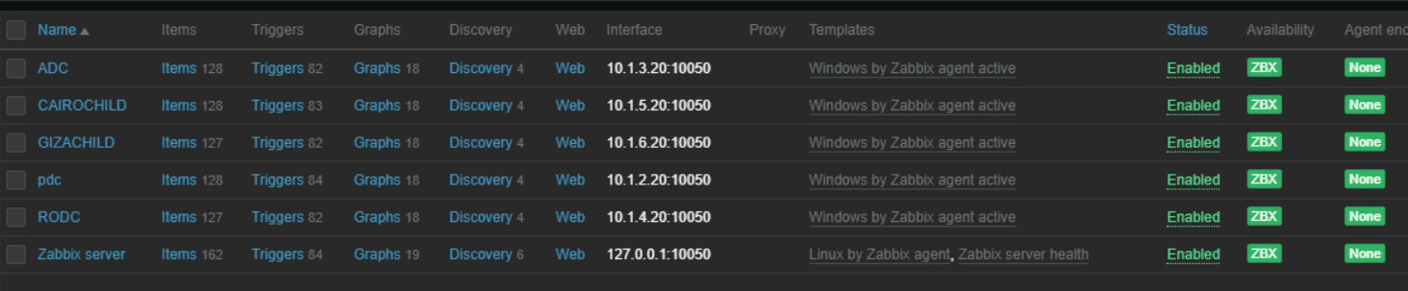
Figure 20: Data collection > Hosts (all five DCs available over the agent)

3.2 Zabbix Agent 2 Configuration
Description
Zabbix Agent 2 is installed on every domain controller and works in active mode with the Windows by Zabbix agent active template. It reports to the Zabbix server at 10.1.7.20 and runs under a group Managed Service Account instead of LocalSystem, so the service has just the rights it needs, with no stored password.
Parameter | Value | Purpose
Server | 10.1.7.20 | Passive checks allowed from
ServerActive | 10.1.7.20 | Active checks / log items
Hostname | Same as the host name in Zabbix | Identity for active checks
Timeout | 30 | Check timeout in seconds
Service account | gMSA - zabbix$ | Runs the agent service

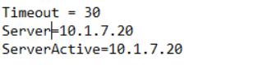
Figure 21: zabbix_agent2.conf (key parameters)
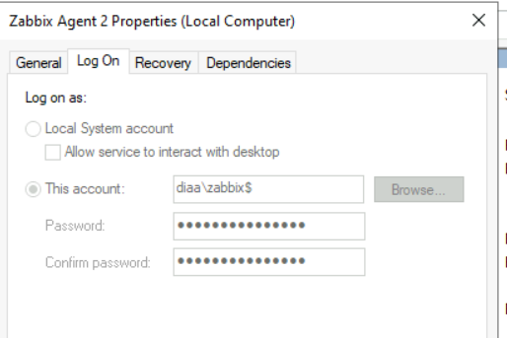
Figure 22: Agent service running as the gMSA

3.3 Service Account (gMSA) & Access
The agent runs under a Group Managed Service Account so no password is stored or rotated manually.
Component | Configuration
Security group | Zabbix-Agent-Servers - contains the pdc, adc, rodc, cairochild and gizachild computer accounts
gMSA | zabbix — password retrieval allowed for Zabbix-Agent-Servers
Domain groups | Performance Monitor Users, Event Log Readers
File system | Full control on C:\Program Files\Zabbix Agent 2
Service config | sc.exe config "Zabbix Agent 2" obj= diaa\zabbix$ type= own

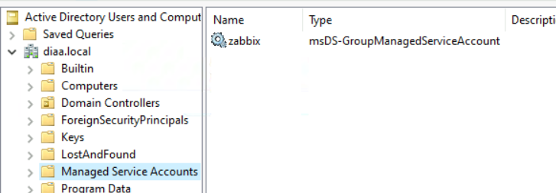
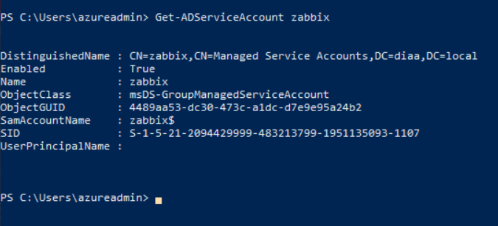
Figure 23: gMSA object and PrincipalsAllowedToRetrieveManagedPassword
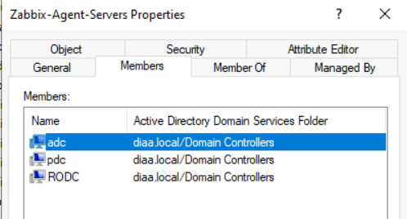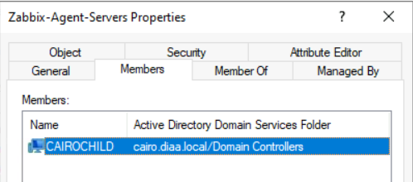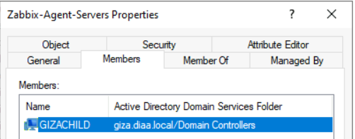
Figure 24: Zabbix-Agent-Servers group membership
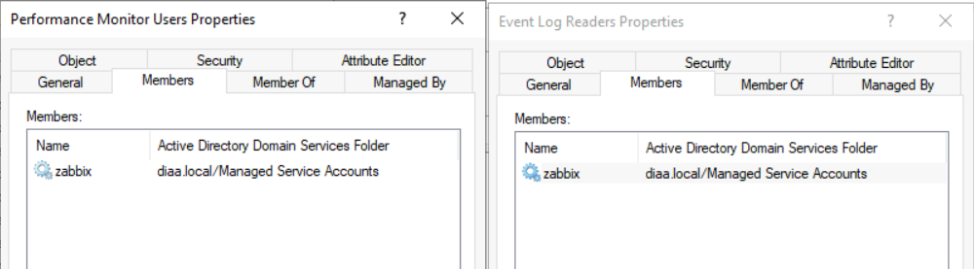
Figure 25: gMSA membership in Performance Monitor Users / Event Log Readers
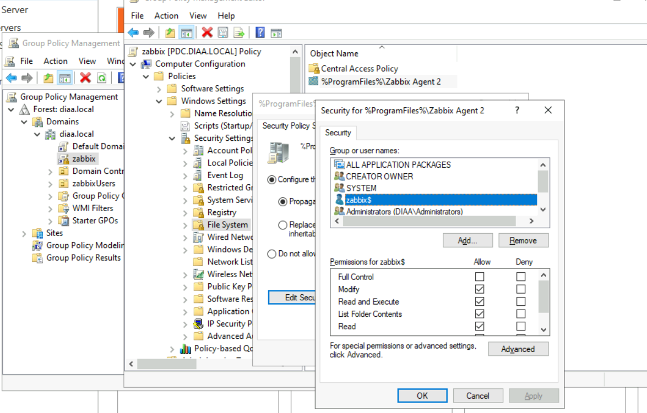
Figure 26: Folder permissions for the gMSA

3.4 Items
Description
On top of the standard template items, three items were added to the Windows by Zabbix agent active template so every domain controller inherits them: the Security event log, the AD DS replication status file, and the Zabbix agent's own log file. All three are Zabbix agent (active) items.
Item name | Key | Type | Interval
eventlog | eventlog[Security] | Zabbix agent (active) | 3s
adds-replication | vfs.file.contents[C:\Program Files\Zabbix Agent 2\scripts\repl_status.txt] | Zabbix agent (active) | 10s
zabbix agent logs | log["C:\Program Files\Zabbix Agent 2\zabbix_agent2.log"] | Zabbix agent (active) | 3s
Template items | CPU, memory, disk, network and service items from the template | Zabbix agent (active) | Template default

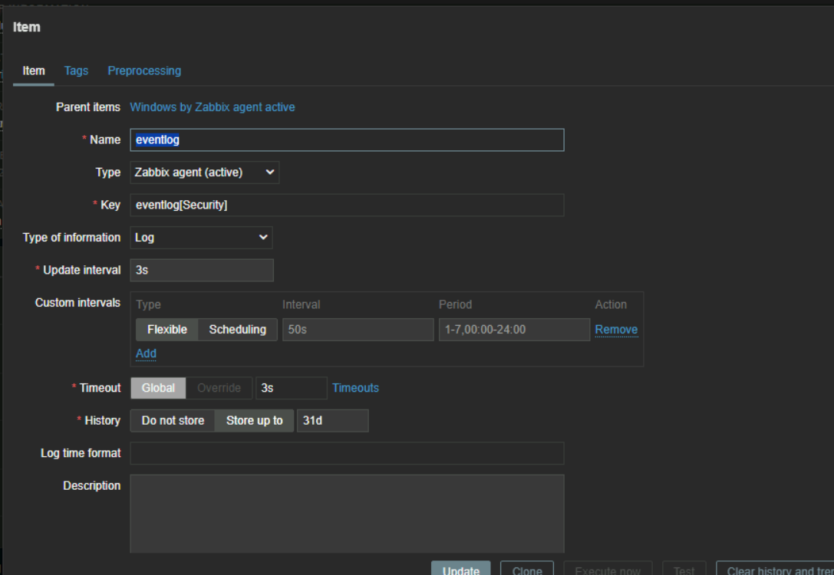
Figure 27: Item configuration - eventlog[Security]
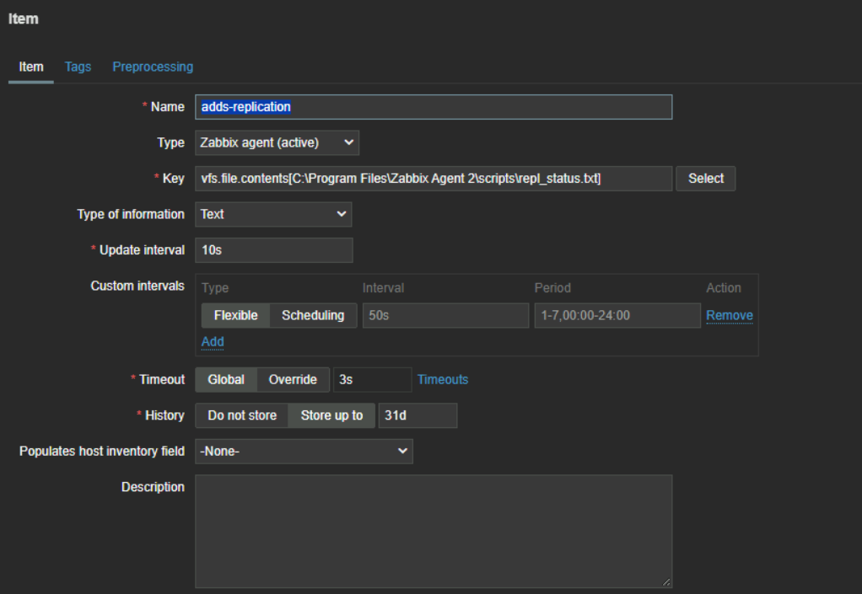
Figure 28: Item configuration - adds-replication (repl_status.txt)
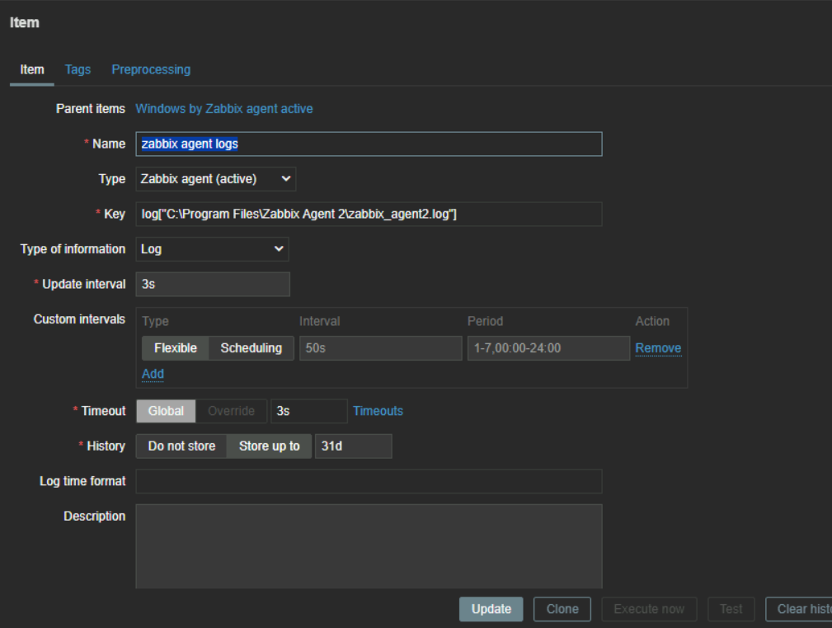 in
Figure 29: Item configuration - zabbix agent log
The adds-replication item reads repl_status.txt, a status file that a script on the PDC fills in with the result of the replication check. When failures are found, the file starts with ALERT and lists the failing partner, the last successful sync and the error code, and the Replication failure trigger (see 3.6) reads it.
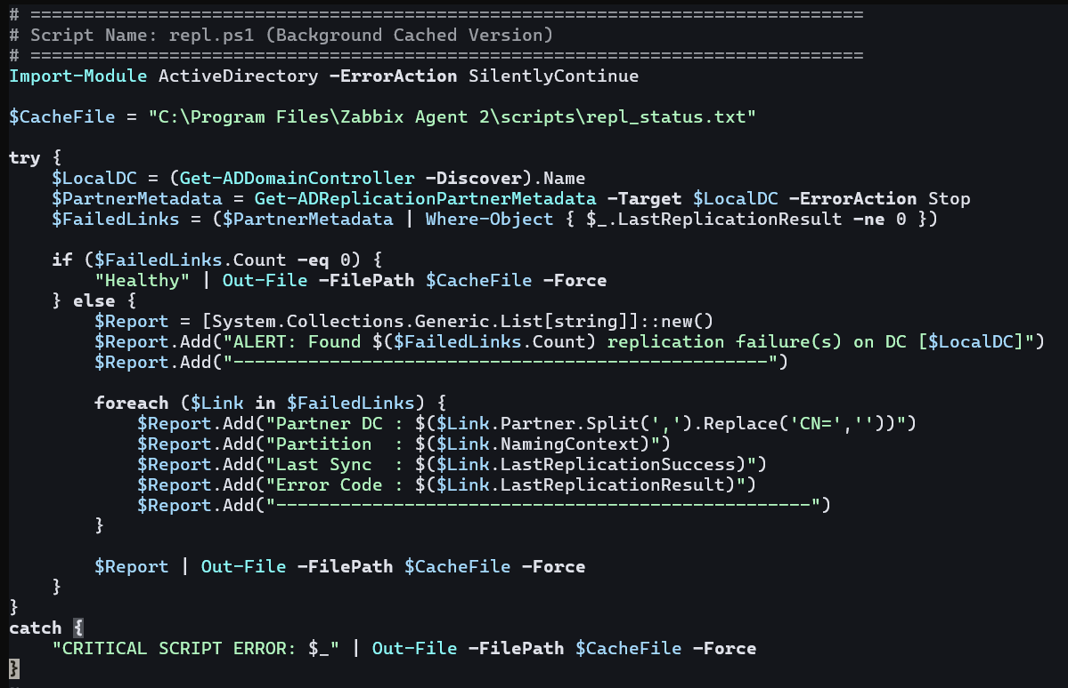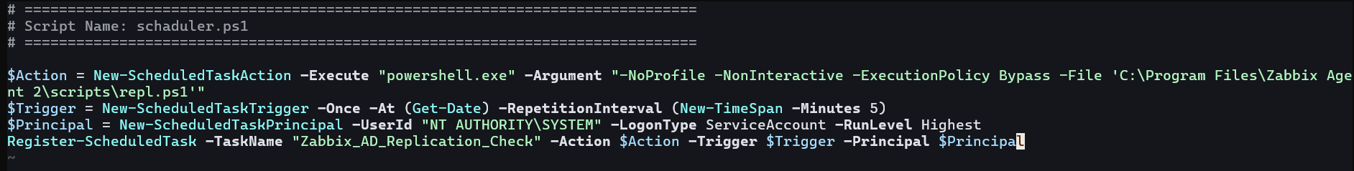
Figure 30: Replication check script and its schedule

3.5 Discovery Rules
Description
A network discovery rule named domain controllers scans 10.1.0.0/16 every minute with a Zabbix agent system.hostname check. Every host that answers is picked up by a discovery action that adds the host, puts it in the domain controllers host group, links the Windows by Zabbix agent active template and sends a Telegram message. This is how all five domain controllers appeared in Zabbix without creating hosts by hand.
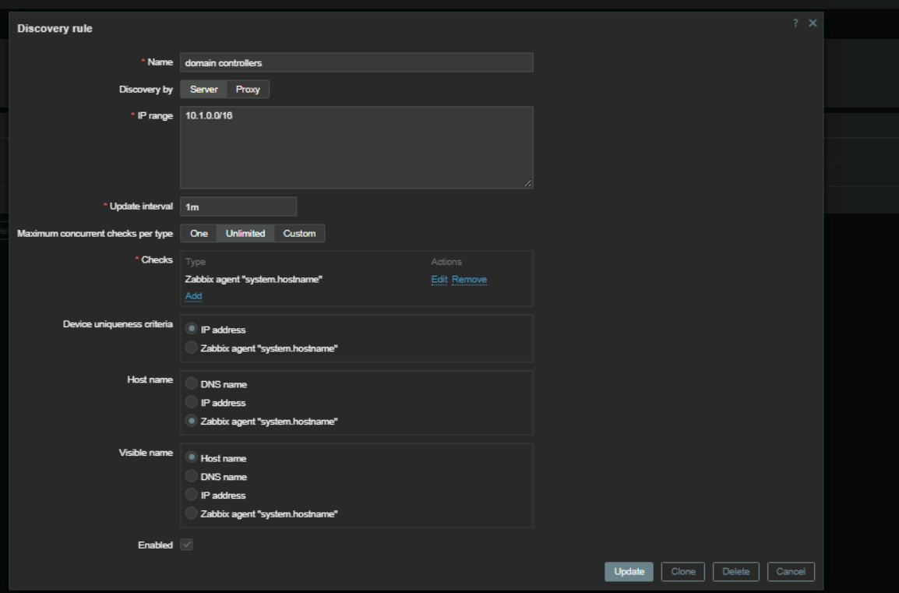
Figure 31: Network discovery rule - domain controllers (10.1.0.0/16)
Figure 32: Discovery action - add host, add to group, link template, notify
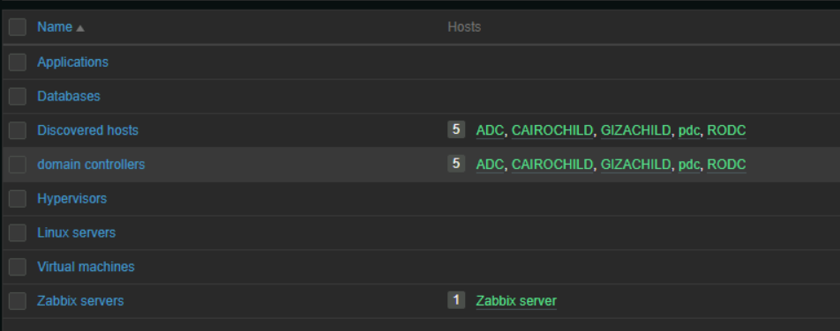
Figure 33: Host groups - the five DCs in domain controllers

3.6 Triggers
Alerting is driven by triggers. Replication failure (Disaster) is a custom trigger on the adds-replication item of the PDC. The template's own triggers, such as agent availability and CPU queue length, use the same notification path.
Trigger name | Expression | Severity
Replication failure | find(/pdc/vfs.file.contents[C:\Program Files\Zabbix Agent 2\scripts\repl_status.txt],#1,"like","ALERT")=1 | Disaster
Windows: Zabbix agent is not available (or nodata for {$AGENT.NODATA_TIMEOUT}) | Template trigger: fires when the active agent stops reporting | High
Windows: CPU queue length is too high (over 3 for 5m) | Template trigger on the CPU queue length item | Warning

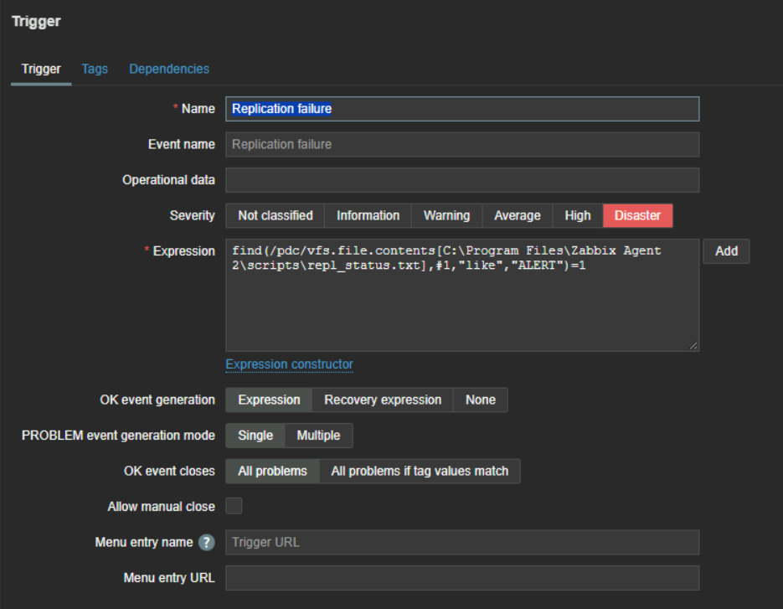
Figure 34: Trigger configuration - Replication failure (expression and severity)

3.7 Telegram Notifications
Description
Alerts are delivered to a Telegram group. A webhook media type (Telegram) uses a bot to post to the group chat, and the Admin user has a Telegram media entry. Three trigger actions send the notifications: agent not sending data, replication failure, and report problems to Zabbix administrators. The last figure shows real alerts received in the Zabbix alerts group.
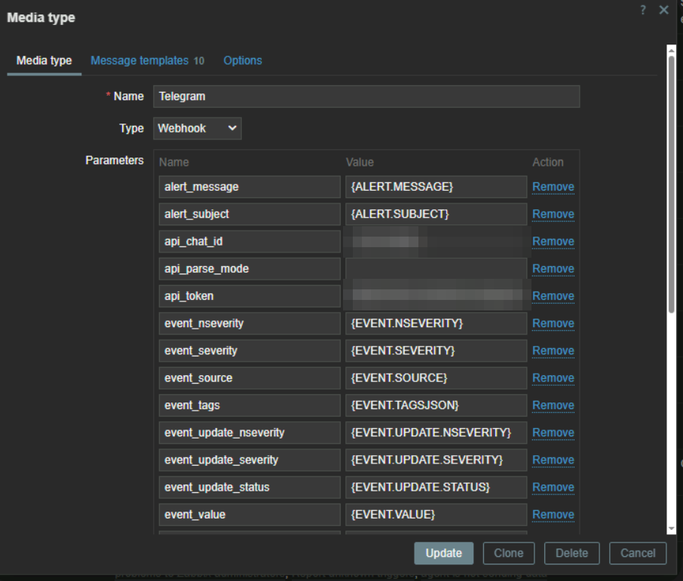
Figure 35: Media type - Telegram webhook (bot token and chat ID blurred)
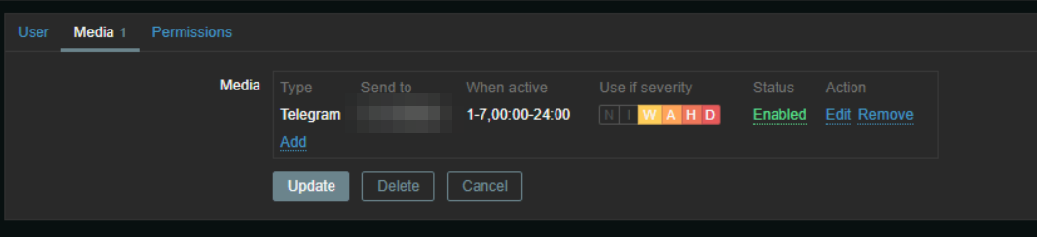
Figure 36: User media - Telegram
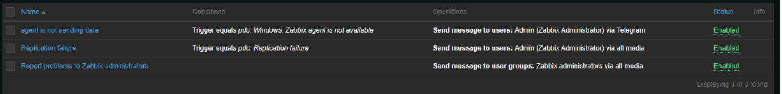
Figure 37: Trigger actions - agent availability, replication failure, report problems
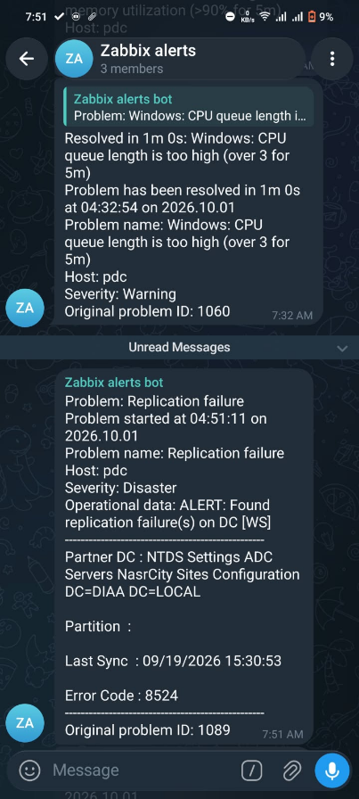
Figure 38: Telegram group receiving the alerts

3.8 Dashboard
Description
A dashboard gathers what matters for the domain controllers on three tabs: Performance (CPU, memory and disk per DC), Logs (Windows Security event log entries) and Agent Logs (the agent log files), so the health of the whole forest can be read in one place.
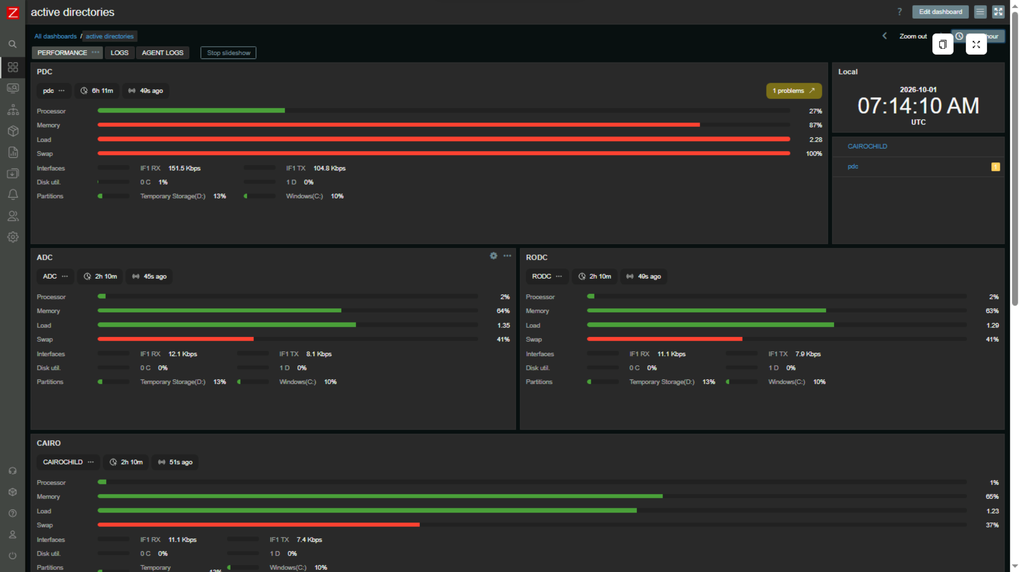
Figure 39: Dashboard — Performance tab
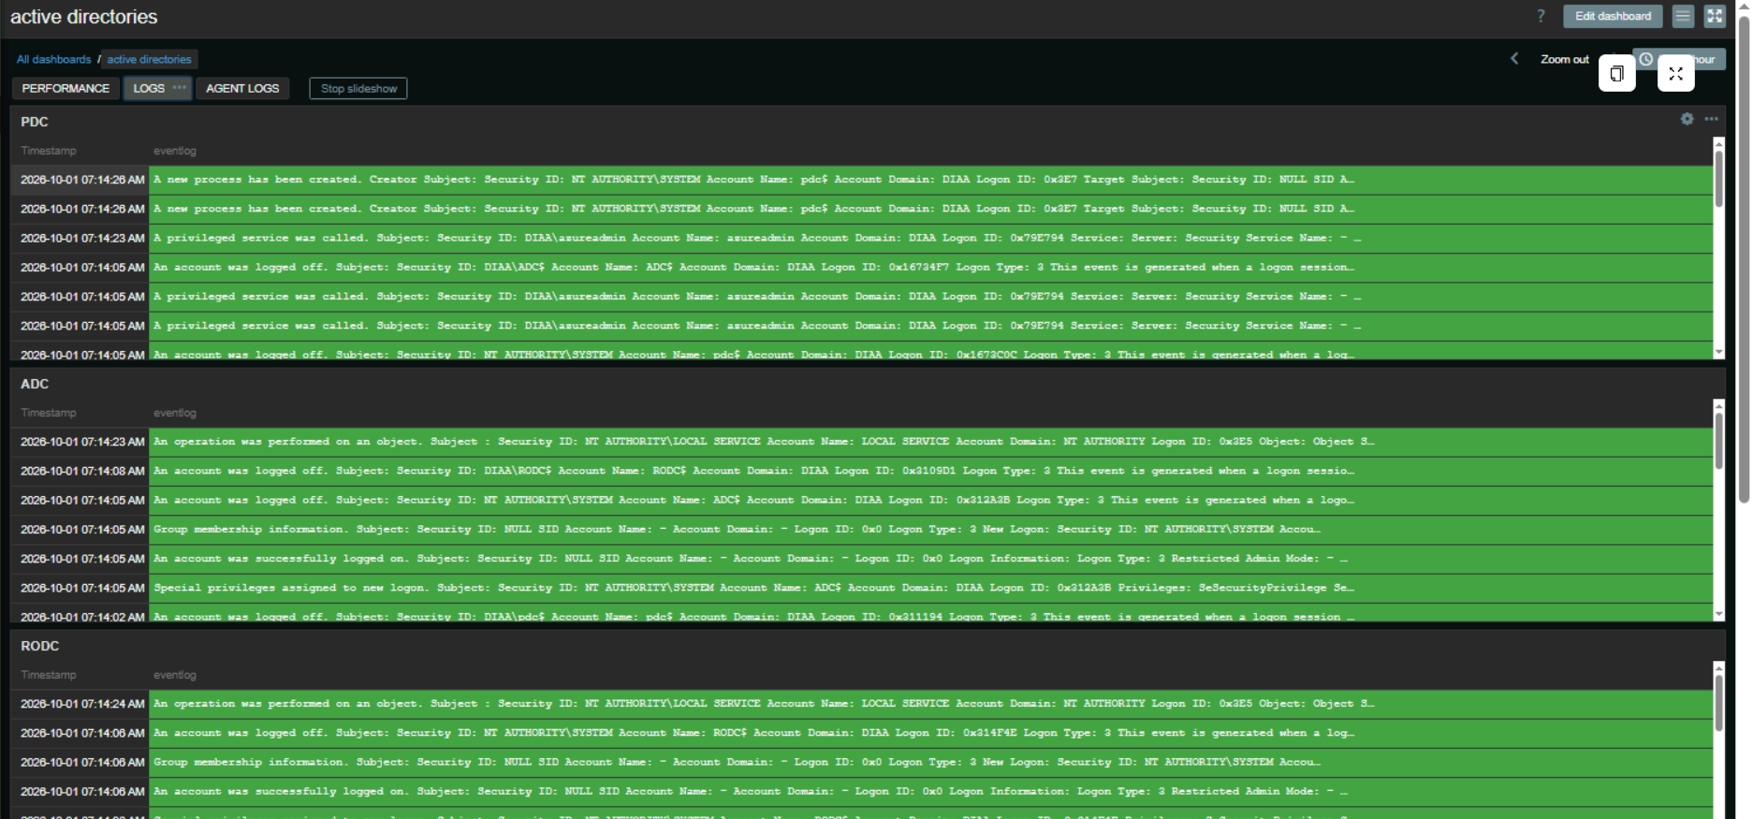
Figure 40: Dashboard — Logs tab
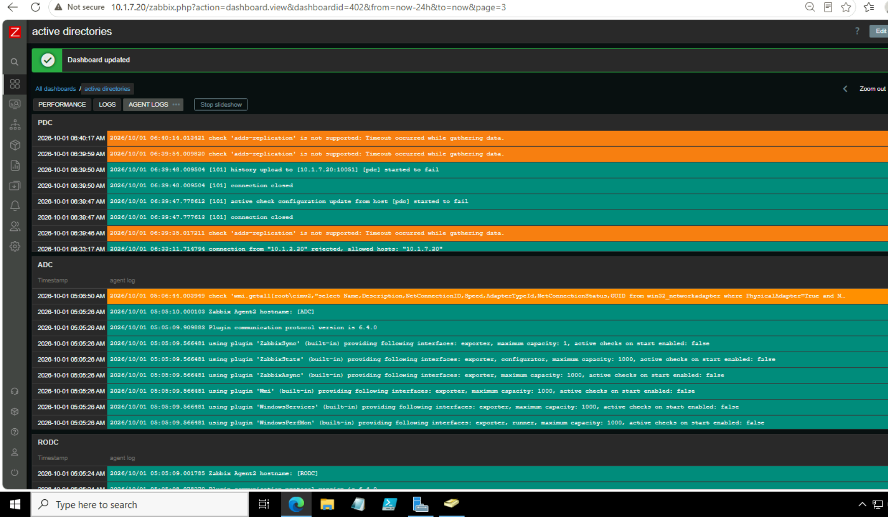
Figure 41: Dashboard — Agent Logs tab

3.9 LDAP Authentication & JIT Users
Description
Zabbix users sign in with their Active Directory accounts. The server uses a bind account to search the zabbixUsers OU, and JIT provisioning creates the Zabbix user at the first successful login and assigns the user group and role from the AD group: zabbixUsers maps to Zabbix administrators (Super admin role) and zabbixGuests maps to Guests (Guest role).
Setting | Value
LDAP server | 10.1.2.20 (pdc), port 389
Base DN / search attribute | OU=zabbixUsers,DC=DIAA,DC=LOCAL / sAMAccountName
Bind DN | CN=zabbix-search,OU=zabbixSearch,DC=DIAA,DC=LOCAL
JIT provisioning | Enabled - group mapping via memberOf
Deprovisioned users group | Disabled
Default authentication | LDAP - local accounts denied

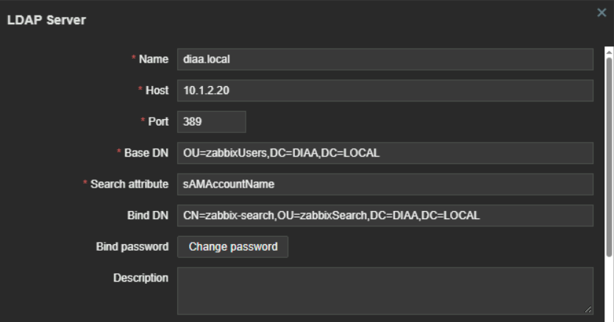
Figure 42: Authentication → LDAP settings

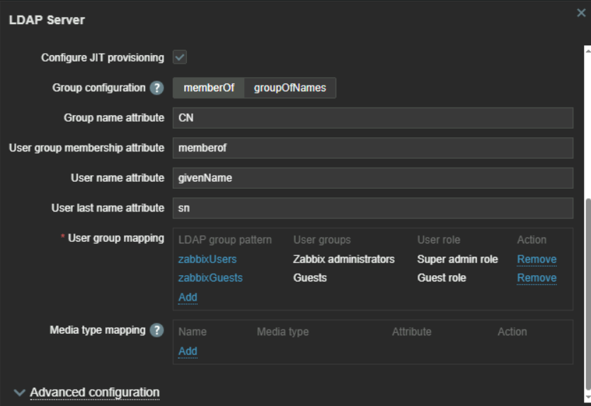
Figure 43: Group mapping (memberOf → user group / role)
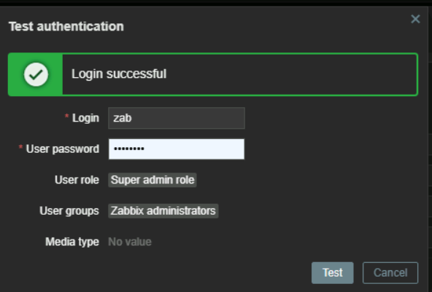
Figure 44: Successful LDAP login
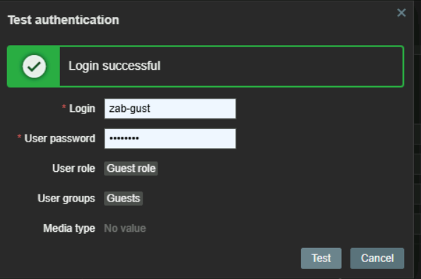
Figure 45: Second test user: different group, different Zabbix role
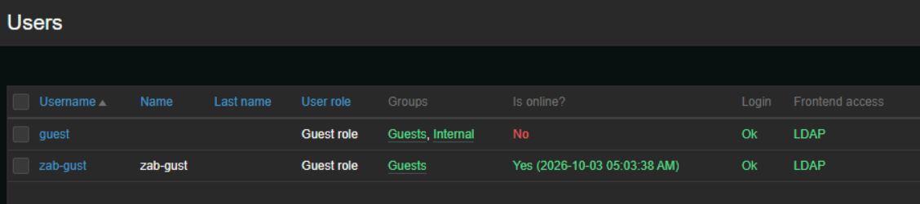
Figure 46: Users created automatically by JIT (frontend access: LDAP)

3.9.1 LDAP Bind Account vs gMSA
The LDAP bind uses a regular service account rather than a gMSA. Zabbix runs on Linux and its LDAP settings need a fixed bind DN and password: a gMSA password is retrieved and rotated by Windows for domain-joined servers, so it cannot be used here.
 | Agent account | LDAP bind account
Type | gMSA (zabbix$) | Regular service account
Used by | Zabbix Agent 2 Windows service | Zabbix server (Linux) LDAP search
Password | Auto-rotated by AD | Static, long and random, no expiry
Why this type | Windows service on domain-joined DCs | Zabbix needs a fixed password in its config

Hardening applied to the bind account:
- Least privilege: plain Domain Users member, no admin rights; default directory read access is enough for search
- Password: long and random, set to never expire and user cannot change it, so Zabbix is not locked out by expiry
- Placement: the account lives in its own zabbixSearch OU, separate from the zabbixUsers OU that Zabbix searches
- Logon restrictions: interactive and remote logon denied, so the account can only be used to bind
- Transport: plain LDAP on port 389 in this lab, so the bind password crosses the VNet in cleartext. LDAPS on port 636, with a certificate on the DC, is the recommended improvement

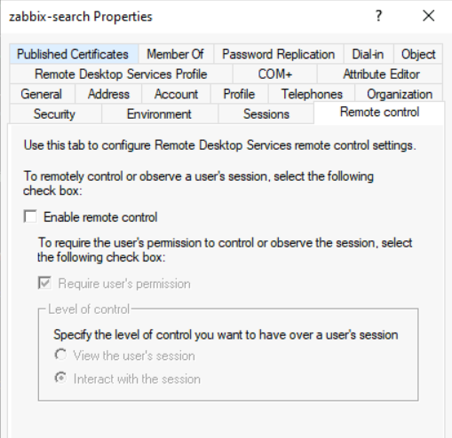
Figure 47: Bind account (zabbix-search) properties

3.10 Logs
Description
Windows Security event logs and the Zabbix agent log files are collected into Zabbix as log items, so authentication activity and Zabbix's own errors can be reviewed in the same place as the metrics. The first figure shows Security event log entries received from a domain controller, the second the agent log file contents.
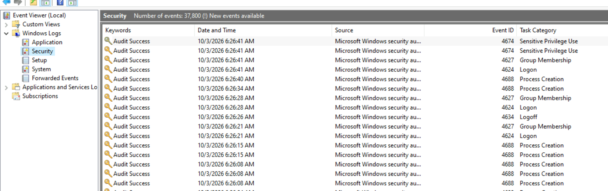
Figure 48: Windows Security event log entries collected by Zabbix
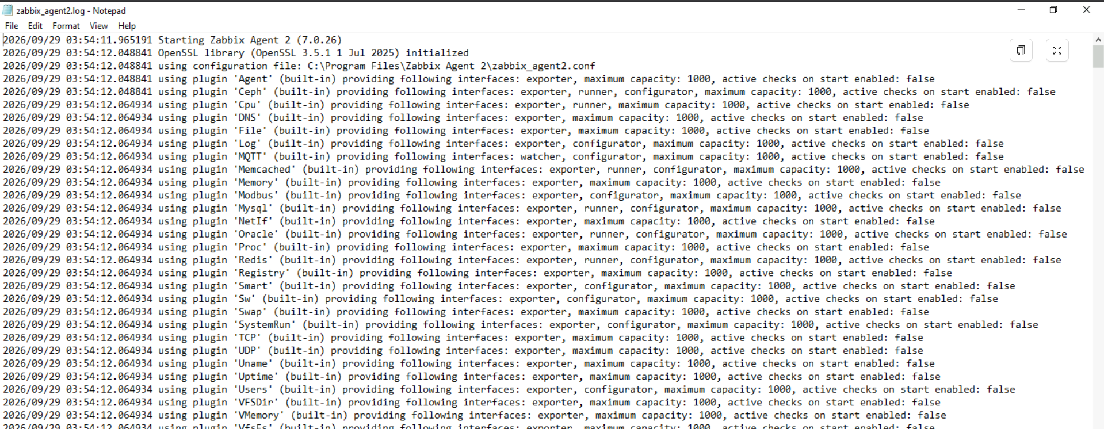
Figure 49: Zabbix agent log file contents (log item)

4. Testing & Validation
Test | Expected result | Actual result | Pass?
Stop replication / DC offline | Zabbix trigger fires + Telegram alert | Replication failure (Disaster) raised for the PDC and delivered to the Telegram group (Figure 38) | Pass
Domain user logs in to Zabbix | JIT account created | Test login succeeded with the AD password (Figure 44); the JIT-created user is listed with LDAP access (Figure 46) | Pass
Local Admin login attempt | Denied (LDAP-only) | Can’t authenticate | Pass
RODC password caching | Only allowed accounts cached | Advanced PRP lists only 3 cached objects (Figure 17) | Pass
Login as user 1 vs user 2 | Different Zabbix roles via group mapping | zab: Super admin role, Zabbix administrators. zab-gust: Guest role, Guests (Figures 44, 45) | Pass
FSMO transfer to ADC | netdom shows Infrastructure Master on ADC | Infrastructure master is adc.diaa.local after the move (Figure 11) | Pass

5. Troubleshooting Log
Issue | Cause | Fix
Access Denied installing gMSA on a DC | Stale Kerberos ticket cache for SYSTEM | klist purge -li 0x3e7, then reinstall the gMSA
Agent service failed to start under gMSA | No permission on the agent folder | Granted the gMSA control on C:\Program Files\Zabbix Agent 2
eventlog[Security] Not supported | Item type / ServerActive not applied | Set item type to Zabbix agent (active) and fix ServerActive in the agent config

